**Glossary:**

* Hone – отточить
* Initiates – посвящённые
* Eloquent – красноречивый
* Solely – исключительно
* Gained – приобрести
* Edible – съедобный
* Variables – переменные
* Coincide – совпадать
* Simultaneous – одновременно
* Incomprehensible – непостижимый
* Counterparts – двойники/собратья
* Sinned – грешить

**Strange programming languages**

When developers get tired of the standard serious PL, they start coming up with new, more unusual and interesting alternatives. And this is not only for fun, it can be useful too.

And speaking specifically, the benefit of such exotics lies in the fact that with its help programmers study the limits of the possibilities of languages and hone their skills even more effectively. After all, strange languages usually have a more complex syntax and therefore are understandable only to a small group of initiates.

Intrigued? Then let's get to know them in more detail.

**WHITESPACE**

Creations of this category usually have eloquent names. Whitespace (”space" in Russian translation) is no exception. In 2002, two comrades decided to create a language based solely on non-printable characters. The public then considered this idea just a joke, but the language was not only born, but also gained some popularity. Meanwhile, Whitespace has not won an international calling.

**CHEF**

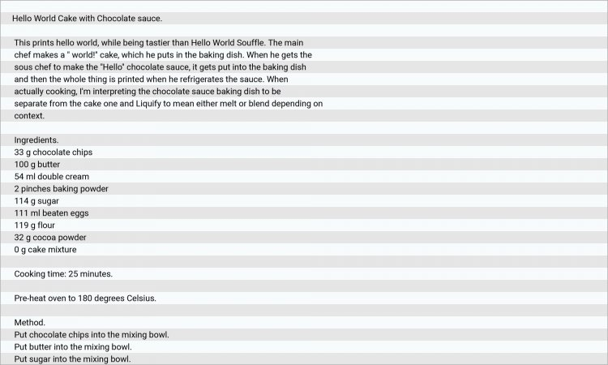

A very funny PL created for those who like to cook and want to learn how to program. It is similar to a culinary recipe and is based on the following principles:

* the output data generated by the code should not only have a technical benefit, but also be tasty and easy to prepare;
* recipes should differ by budget;
* the code should act like a normal code, but at the same time be edible.

Would you like to try the chocolate cake "Hello World"?

**SHAKESPEARE**

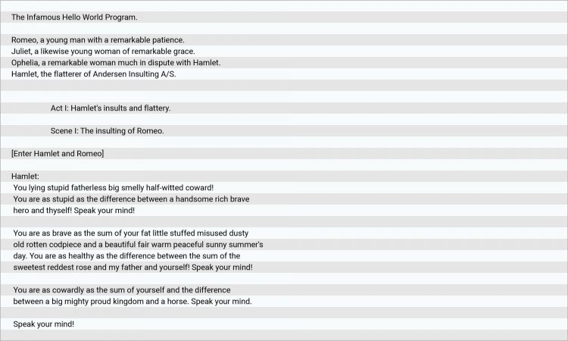

The names of variables in Shakespeare coincide with the names of the characters in his texts. Their interaction takes place in scenes where input and output acts are performed, questions are asked and answers are received. According to the rules, simultaneous work can be with no more than two Shakespearean characters.

**CHICKEN/OOK**

And here you will see only one word — chicken. Apart from chicken, the code page does not contain any other characters. The Swedish developer created this language after a parody of D. Zongker's scientific reports.

OOK is built on the same principle, but it has 4 variations of this word:

* Ook, (with a comma)
* Ook!, (with an exclamation mark and a comma)
* Ook. (with a dot)
* Ook? (with a question mark)

It was reported that this unique tool was created exactly in order to be available for use by orangutans. Yes, you got it right, and it's not humor.

**INTERCAL**

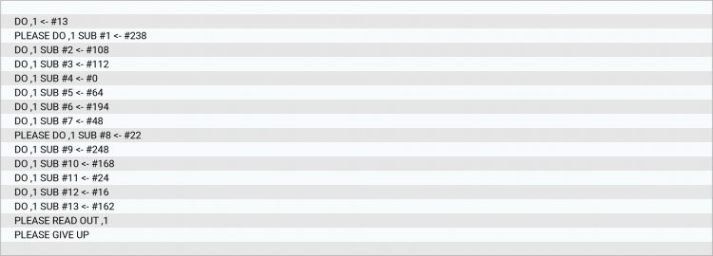

If in the previous examples the algorithms of the languages were very incomprehensible, then here they are quite standard. The only thing that distinguishes Intercal from its more serious counterparts are small "surprises". The irony is that it implies the use of completely useless words (which, by the way, many codes sinned at the time of the origin of programming). For example, in some version it is necessary to write to the computer "please" for each of the operations, otherwise it will not perform them.

**ENGLISH**

https://itproger.com/img/news/1635138392.jpeg

The simplest of our PL list, because it imitates natural English. The free syntax is very convenient and gives the developer a huge freedom of expression.

**MALBOLGE**

https://itproger.com/img/news/1635138386.jpeg

So the moment has come when there is no laughing matter at all. The name is taken from Dante's brilliant work "The Divine Comedy”, in which the word “Malbolge" was called the 8th circle of hell, in which there were deceivers. As you can see from the example, it is almost impossible to create even a simple program in this language. The funny thing is that most of the code written in Malbolge was created using other programs and trivial search.

And the most interesting thing is that these are not all crazy and absurd languages that you can use to write funny codes and train your brain!